Public Service Commission
Electronic Case Filing Initiative
Optimizing PDF Documents

Revised 01/25/06

Overview:

All “PDF” files should be “optimized” for viewing over the Internet. When a non-optimized ‘pdf’ document is accessed via the Internet, the browser attempts to download the entire document before displaying any of the text. For large documents or slow Internet connections, this can result in an extremely long wait period before the document will open. To address this performance issue, documents should be “optimized” for efficient downloading. When optimized, the browser will start displaying the first page as it is downloaded, allowing the user to begin reading the document, while the remainder of the document finishes downloading in the background.

Optimizing PDF documents - Adobe Acrobat Version 7:

Adobe “pdf” documents created directly from within a word processing document will be created as “optimized” by default. However, if your documents are created from scanning pages into Adobe Acrobat, you will need to “optimize” the documents by performing a “Save As” operation from within Acrobat when you save the document to disk.

In order for the “Save As” function to create an optimized “pdf” document, you must check your default settings for optimizing Adobe Acrobat files by the following steps:

Click the “Start” button on your Windows Task Bar
Choose Programs, choose Adobe Acrobat
From the Acrobat Menu Bar, choose “Edit”, then “Preferences” from the drop-down selection list. The following screen should appear:

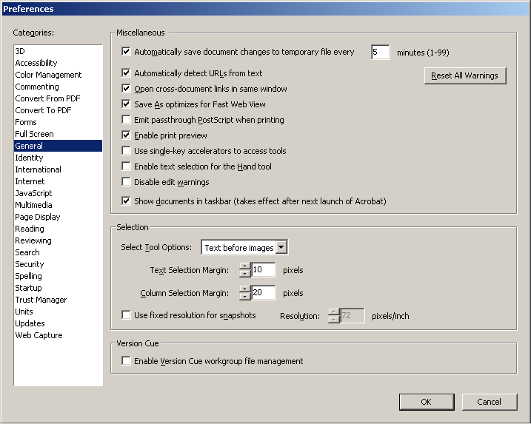

Choose the selection from the leftmost column labeled “General”. Ensure that the setting for “Save As Optimizes for Fast Web View” is checked.

Click the “OK” button to save any changes.

To create Adobe Acrobat documents in a format “optimized” for downloading via the Internet, always choose “File”, “Save As” from the Acrobat menu bar when finished preparing your document.

Follow the steps below to confirm that any “pdf” document is optimized:
Open the document in Adobe Acrobat
From the Acrobat Menu bar, choose “File”, “Document Properties”.
Confirm that the property labeled as “Fast Web View” in the lower right corner is set to “Yes”

Optimizing PDF documents Adobe Acrobat Version 5:

The following references apply to Adobe Acrobat Version 5. Other versions should operate in a similar manner, however you may wish to consult the “Help” feature in your version of Acrobat for full details. Please note that these instructions do not apply to the Acrobat Reader product.

When creating “pdf” files from word processing documents, we recommend using the Acrobat Distiller program as opposed to the Acrobat PDF Writer. Unless default options have been changed, Distiller will automatically create pdf documents in optimized format. When printing your word processing document, simply choose the printer selection named Acrobat Distiller from your print menu and supply a name and location for the “pdf” file.

Note: Acrobat Distiller installs by default from the Adobe Acrobat CD. To install the Acrobat PDF Writer product, you must choose the “custom” installation, when installing the Adobe product.

After installation, confirm that your Distiller options are set to create an optimized “pdf” file as follows:

Click the “Start” button on your Windows Task Bar
Choose Programs, Choose Acrobat Distiller
From the Distiller Menu Bar, choose “Settings”, “ Job Options”
The entry titled “Optimize for Fast Web View” should be enabled as in the following screen sample:

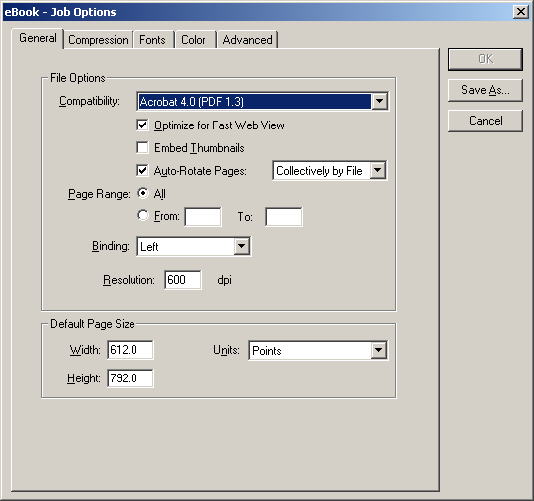

If word processing documents are printed using the Acrobat PDF Writer printer selection or if your documents are created from scanning pages into Adobe Acrobat, you will need to “optimize” the documents by performing a “Save As” operation from within the Adobe Acrobat product.

Check your default settings for optimizing Adobe Acrobat files by the following steps:

Click the “Start” button on your Windows Task Bar
Choose Programs, choose Adobe Acrobat
From the Acrobat Menu Bar, choose “Edit”, “Preferences”, then “General” from the drop-down selection list. The following screen should appear:

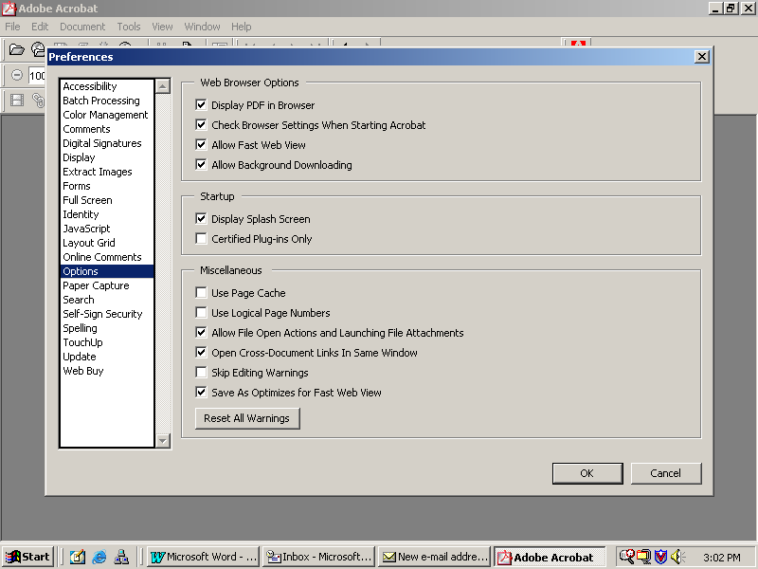

From the left-most column, select the “Options” entry and confirm that your options are checked as in the example above, especially the last entry titled “Save As Optimizes for Fast Web View”.

Click the “OK” button to save any changes.

To create Adobe Acrobat documents in a format “optimized” for downloading via the Internet, choose “File”, “Save As” from the Acrobat menu bar when finished preparing your document.

Please note that you must choose the “Save As” option in order for your “pdf” document to be saved in optimized format, as choosing “File”, “Save” will not yield an optimized document.

Follow the steps below to confirm that your “pdf” document is optimized:
Open the document in Adobe Acrobat
From the Acrobat Menu bar, choose “File”, “Document Properties”, “Summary”
Confirm that the property titled “Fast Web View” in the lower right corner is set to “Yes”

